(Lab 1.1) S-DES Problem

Using the 10 bit key **1010000110**

Encrypt the following 8 bit plaintext using the Simplified DES (S-DES) cipher **10000110**

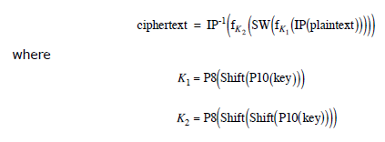

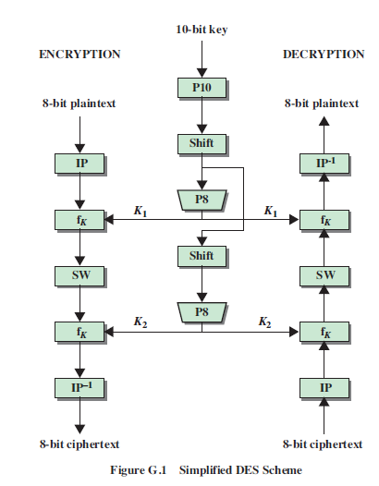

**Key Generation**

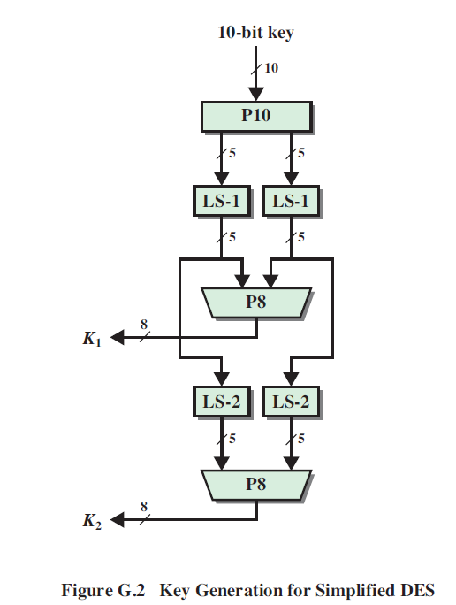

The P10 permutation is defined as



P8 is given by



**K1 = 1 0 1 0 1 1 0 0**

**K2 = 1 1 0 0 0 0 1 1**

**S-DES Encryption**

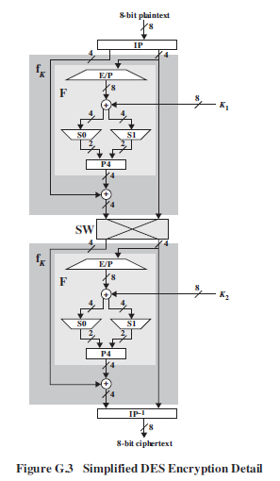

**The initial permutation IP is defined as (from which IP-1 can easily be deduced)**

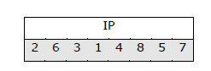

**E/P is defined as**

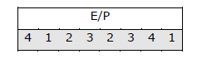

**The S boxes are given as**

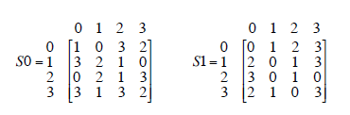

**And P4 is defined as**

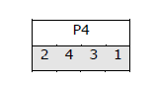

**Ciphertext = 0 0 1 0 0 0 1 1**

**Challenge: (5 points extra credit on midterm). Write a program to encrypt any 8-bit plaintext with any 10-bit key. (Due by the midterm)**